PAPER NAME
Author 1 name, surname
Place of work, address, e-mail
Author 2
Author 1 name, surname
Place of work, address, e-mail

Annotation
Text of annotation. Text of annotation. Text of annotation Text of annotation. Text of annotation.

.
- Introduction
Text.
- Heading
Text.

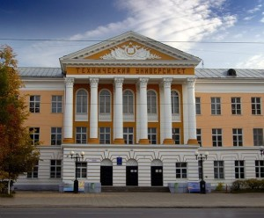
Picture 1. – Name of picture.

Text. Text Text Text Text Text
- Conclusion and future work
Text.

Literature
- Source 1.
- Source 2.

